2303A51830
Lab assignment 8.3
Task 1: Email Validation using TDD
Scenario
You are developing a user registration system that requires reliable email input validation
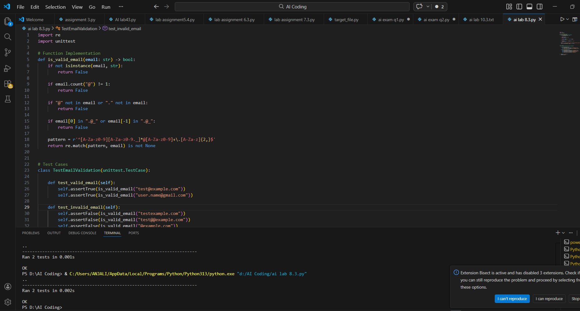
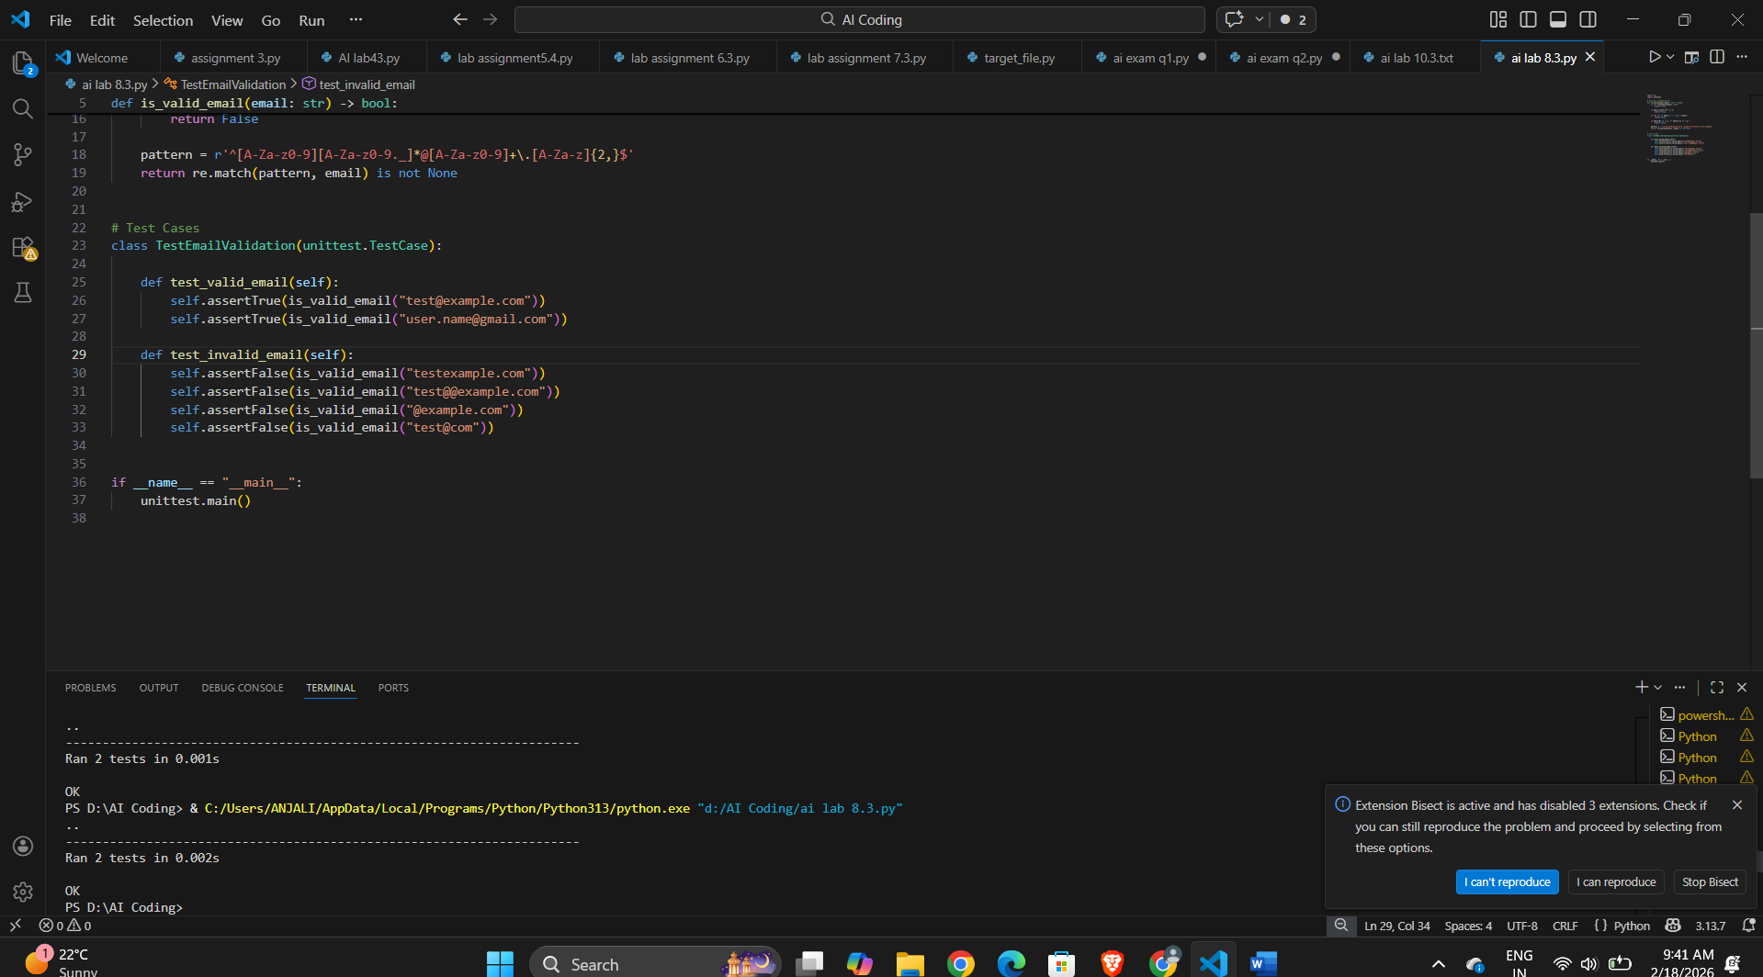
Task 2: Grade Assignment using Loops
Scenario
You are building an automated grading system for an online examination platform.
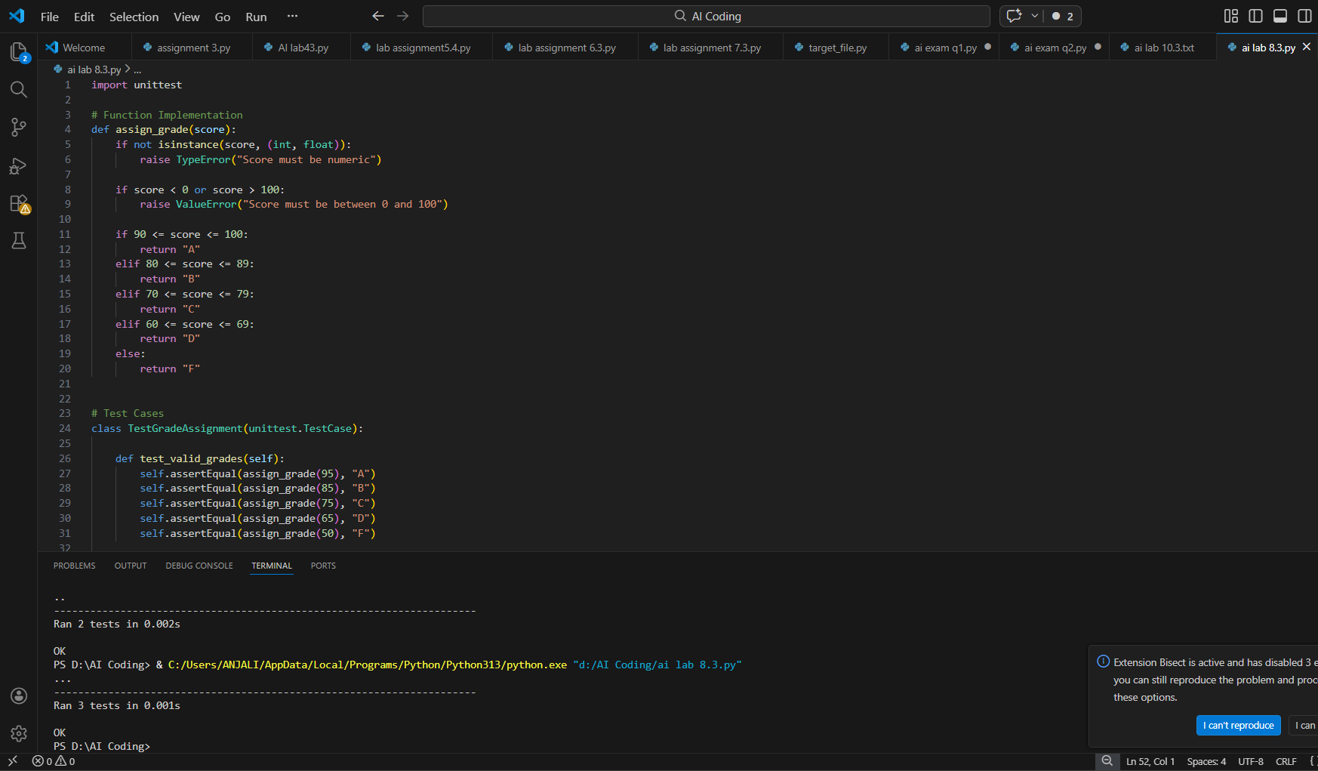
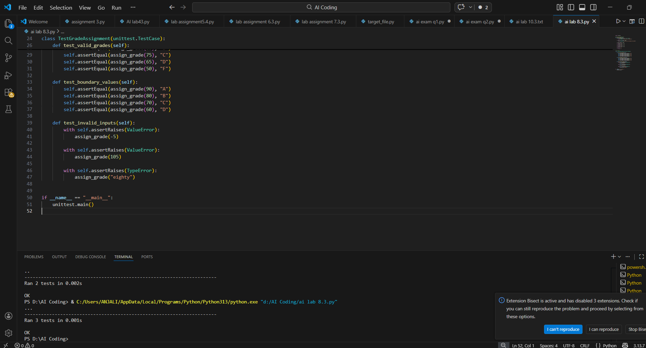

Task 3: Sentence Palindrome Checker
Scenario
You are developing a text-processing utility to analyze sentences.
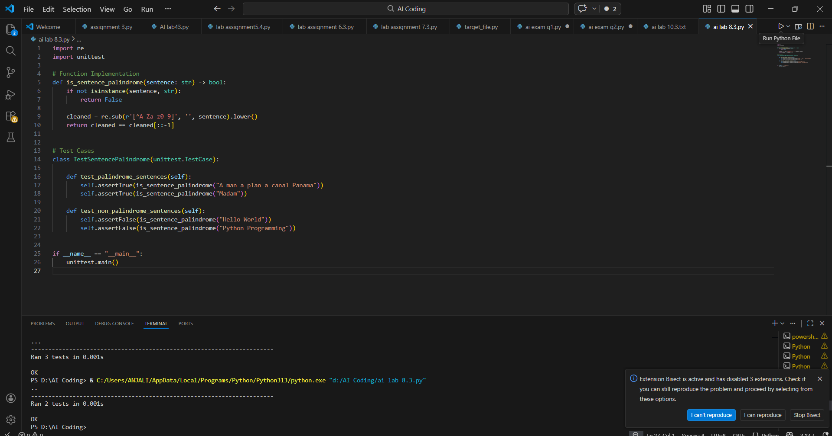

Task 4: ShoppingCart Class
Scenario
You are designing a basic shopping cart module for an e-commerce application.
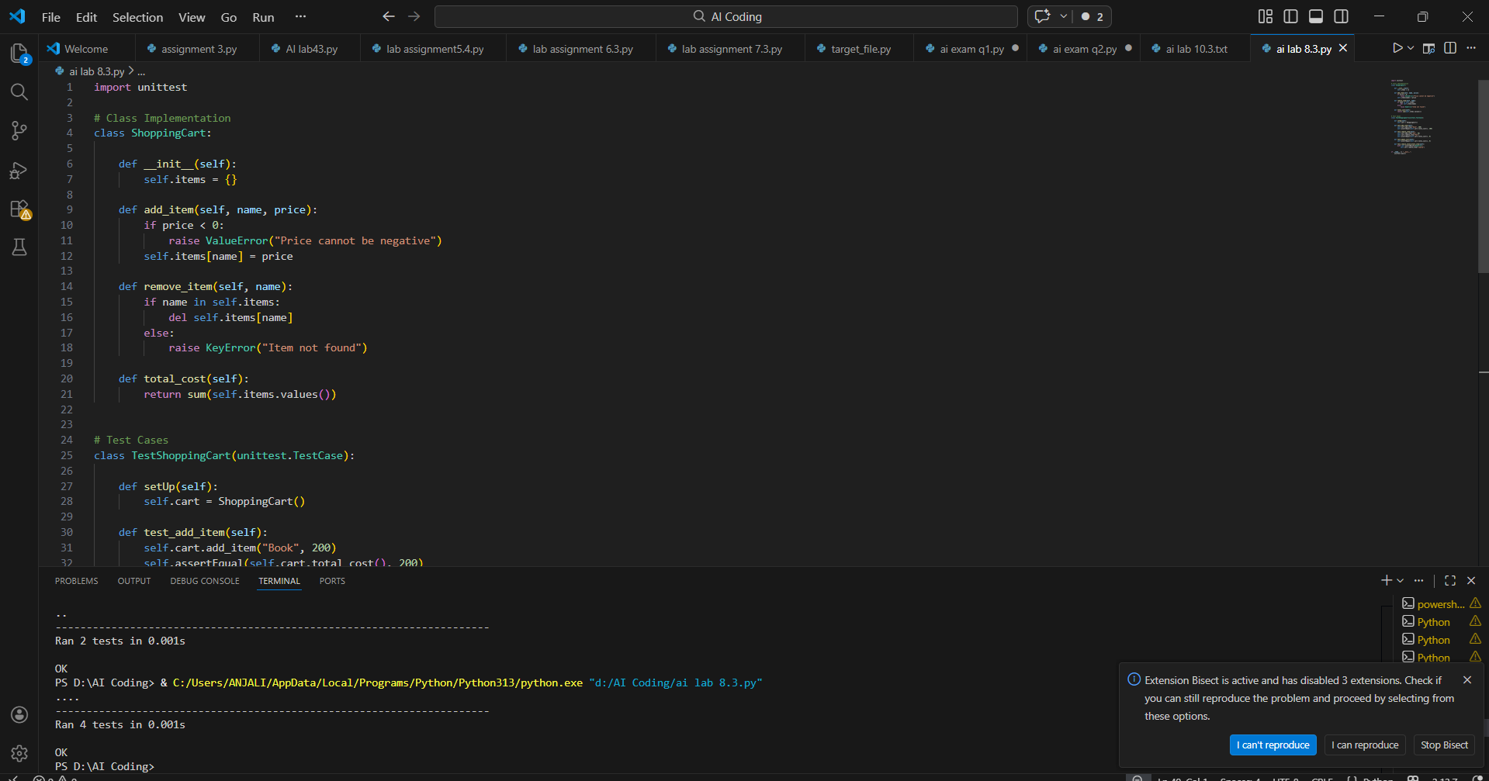
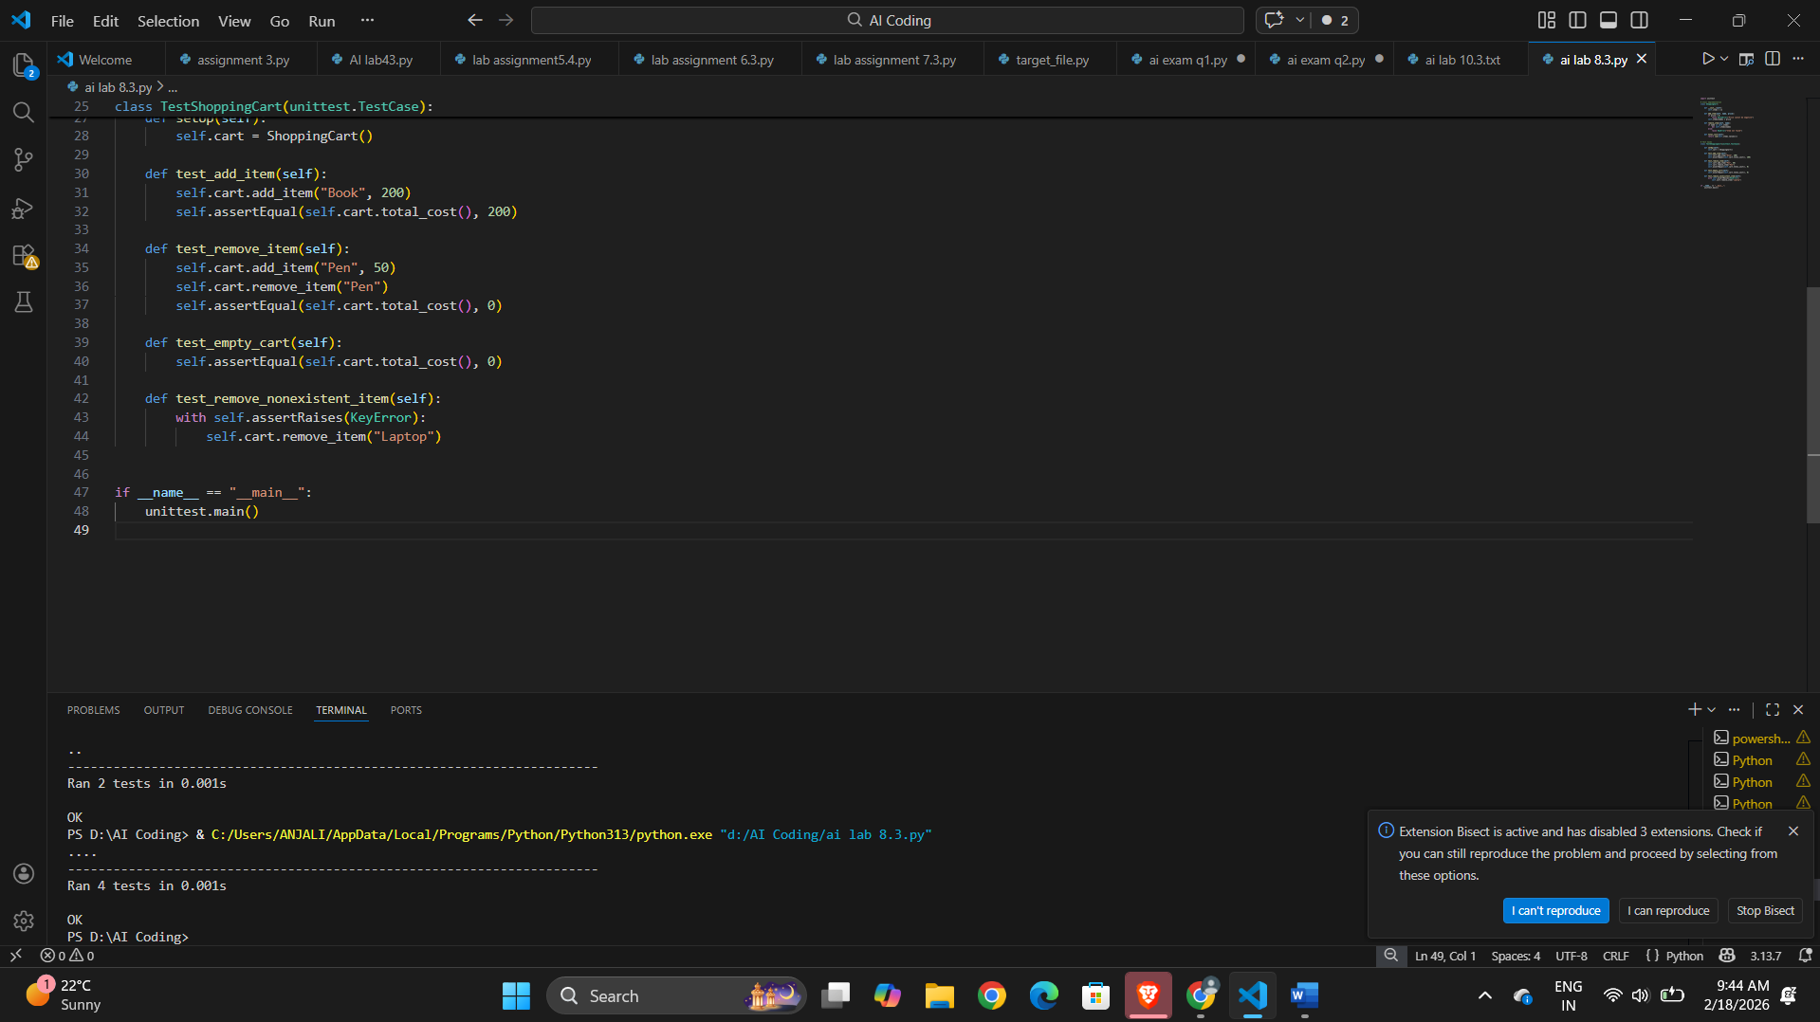

Task 5: Date Format Conversion
Scenario
You are creating a utility function to convert date formats for reports.
